**LA PNO’Z PIZZA SALES QUERIES**

**1. Total number of orders placed.**



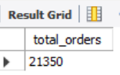

**2. Total revenue generated from pizza sales.**

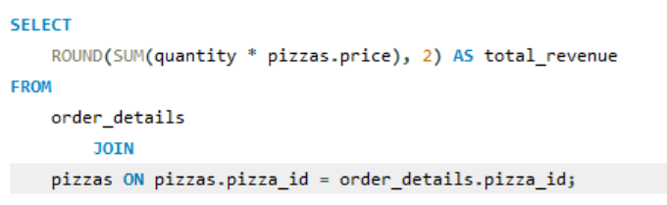

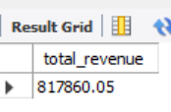

**3. highest-priced pizza.**

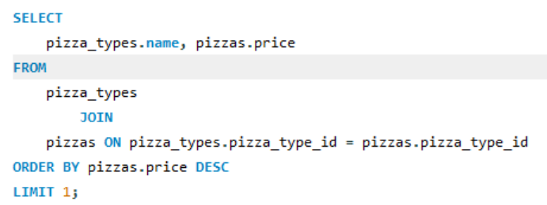

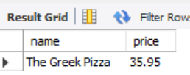

**4.** **Most common pizza size ordered.**

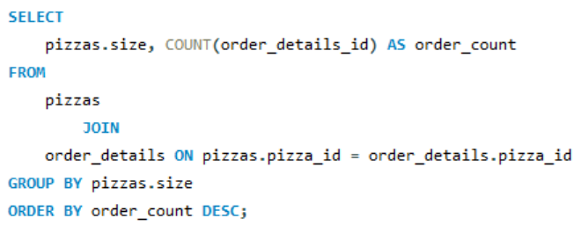

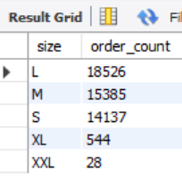

**5. Top 5 most ordered pizza types along with their quantities.**

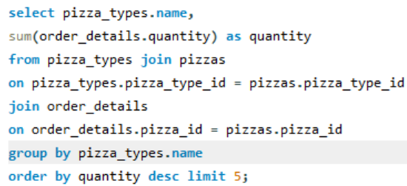

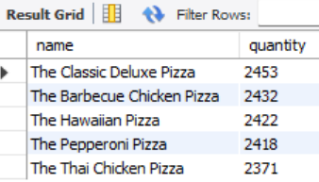

**6. list all pizza categories and the count of pizza types.**

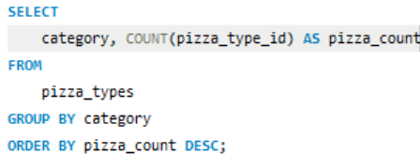

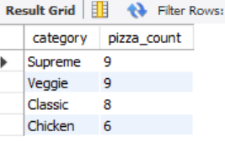

**7. Total quantity of each pizza category ordered.**

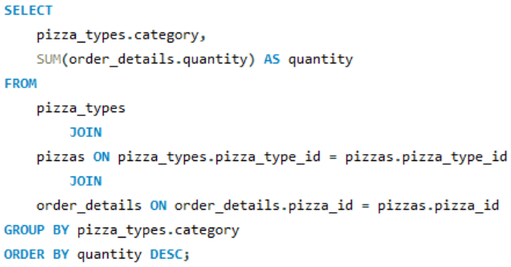

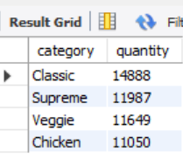

**8.** **Distribution of orders by hour of the day.**

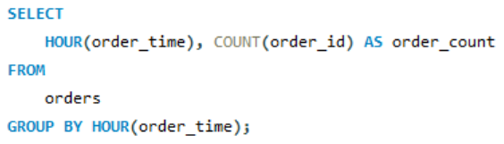

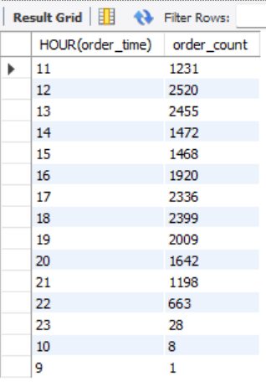

**9. Average number of pizzas ordered per day.**

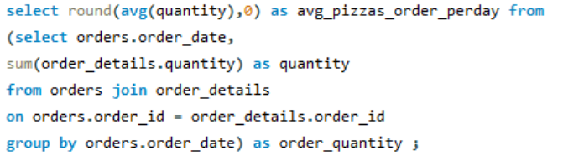

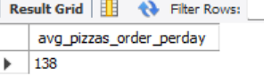

**10.** **Top 5 most ordered pizza types based on revenue.**

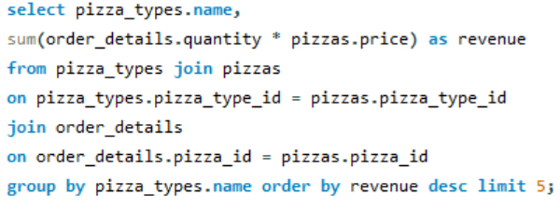

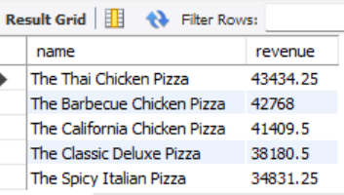

**11.% contribution of each pizza type to total revenue**

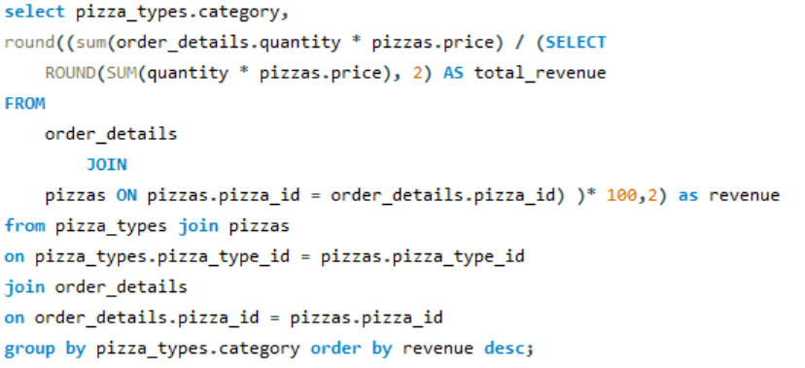

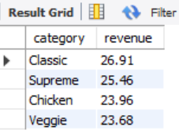

**12.** **The top 3 most ordered pizza types based on revenue for each pizza category**

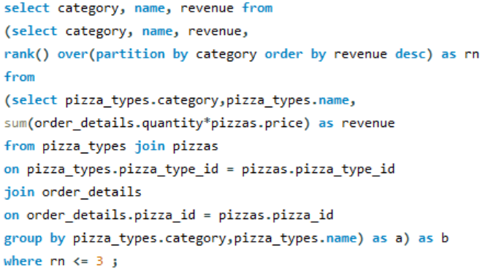

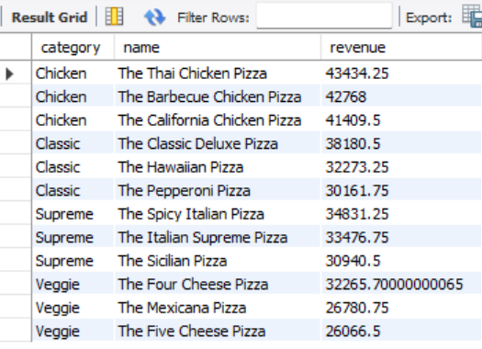

**13.** **Monthly Sales Trend:**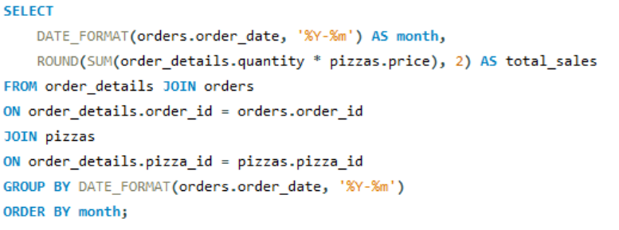

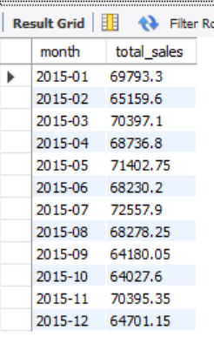

**14. Total Sales by day name:**

